**LOGISTIC REGRESION.**

**Data Set**

Iris data set will be used. It contains 3 classes of 50 instances each, where each class refers to a type of iris plant. To simplify things, we take just the first two feature columns. Also, the two non-linearly separable classes are labeled with the same category, ending up with a binary classification problem.

iris = sklearn.datasets.load_iris()  
X = iris.data[:, :2]  
y = (iris.target != 0) * 1

Using an iris dataset, a graph was plotted to represent all points on the graph as shown below

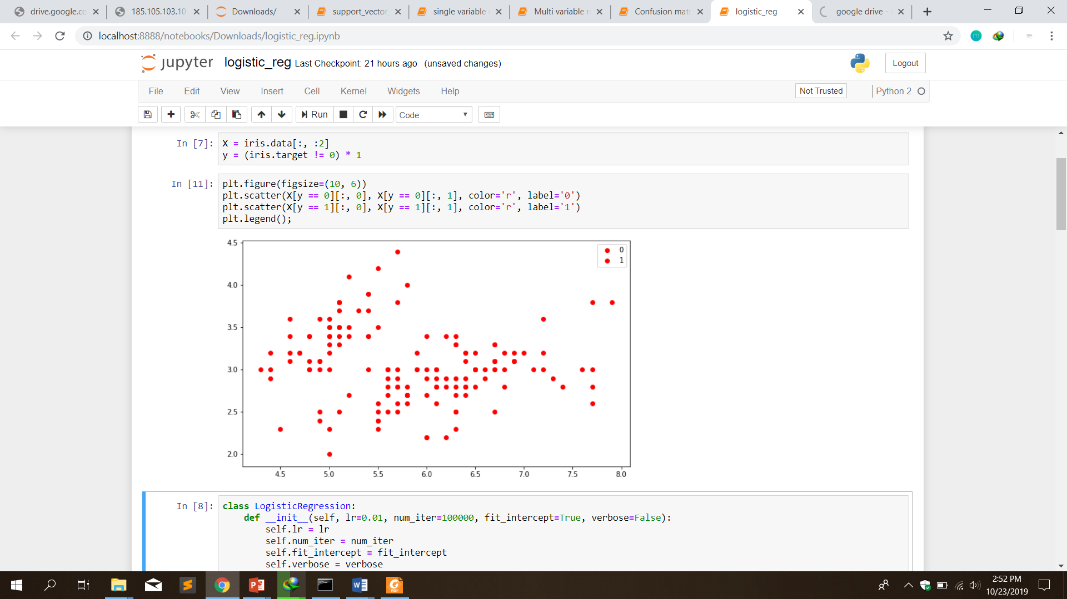

After implementation of the logical regression in python code, a line which is best fit was drawn by the algorithm to show the best possible fit in separating the data input.

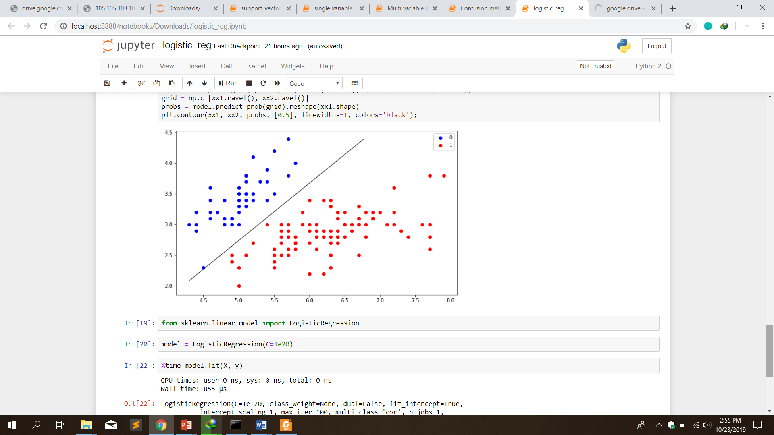

Logical Regression is used without taking the class into consideration. It finds the line that best fits by making sure the lines drawn does not touch any point and not considering the distance of the closes points.